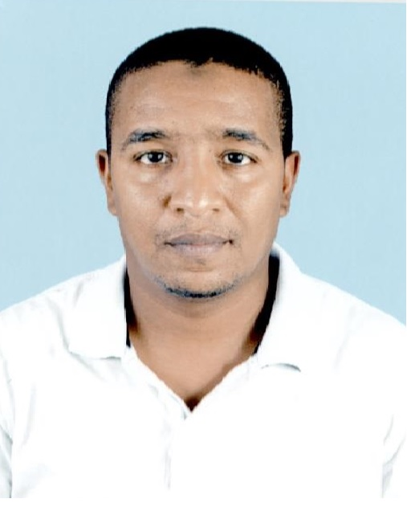Name: Zoheir DEBBA
Date of birth: July 05th 1983
Address: Bloc 476 N° 15-Hay Rimel 01-Touggourt /30200 Ouargla
ALGERIA
E-mail: ezo1983dz@hotmail.com
Tel: +213 770 63 48 39
Family situation: Married

Level school:
- Baccalaureate degree: 2002.
- University studding: From September 2002 to June 2007 at Maintenance and Industrial Safety Institute (IMSI) ORAN.

Diploma:
- State Engineer in Maintenance and Industrial Safety.
- Major: Instrumentation
- Engineer Thesis on: Communication Man / Machine by Terminal MAGELIS

Languages:
- English (speaking, reading and writing).
- French (speaking, reading and writing).
- Arabic (speaking, reading and writing).

Training:

- March 2007: Training about improving the system of command of a boiler. /01 month at SONATRACH/ DP / RHOURD NOUSS. ILLIZI. ALGERIA
- February 2008: Training First Aids. /02 weeks
- January 2010: Industrial Safety Induction. /02 weeks
- From du 23/06/2013 to 27/06/ 2013 : Training about Control system ( PLC) Honeywell

Experience:

- TARKIB CONSTRUCTION PRIVATE COMPANY is consists of:
Construction area Oil and Gas
-Civil Engineering
-Mechanical Engineering
-Instrumentation Engineering
Project Pipeline and Metering in the National Center for Dispatching of Natural Gas (CNDG) SONATRACH /Algeria

I worked as:

Instrument Supervisor: From March 2008 until December 2009
- Supervised the installation of all instruments.
- The wiring from field to automation room.
- Instruments, Metering and DCS commissioning.

- SONATRACH / The National Center for Dispatching of Natural Gas (CNDG) is composed of 11 Pipeline each one consists of:
- Filtration.
- Gas Metering Ramps with orifice plate metering.
- Regulation Ramps with Pressure Control Valve PCV.
- Line Valve and Gas Dispatching.

I worked as:

- Field Instrumentation Engineer: Maintenance of all field instrument and calibration of PCV from 2010 until September 2012 in CNDG
- Senior Field Instrumentation Engineer and Metering: Maintenance of all field instrument and Metering instrument calibration (PT,PDT and TT) and I assist the commissioning and startup of 03 Dispatching Natural Gas Pipeline from September 2012 until January 2015 in the same plant
- DCS Engineer: Recovery Command Control System from backup from 2015 to now

Roles and responsibilities:
- Responsible for complying with all safety, health, environmental policies and procedures of the company.
- Responsible for raising Safety issues inside the plant by raising Stop card.
- Insure good communication between all the team in plant.
- Must know the Personal Protective Elements and HSE in General.
- Attending the departmental safety, health and good housekeeping meetings, participates in plant inspection tours and takes active participation in implementing Company policies on safety, health, loss prevention and quality management.
- Observing all safety, fire and security rules and regulations, including the use of protective clothing and equipment and ensures that all personnel working in my area comply with safety procedures.
- Familiar with all gas dispatching operation and all preventive and curative maintenance procedure.
- Prepare Permit to Work for Senior Instrument Technician approval and perform operations and maintenance activities in accordance with established company Quality Systems and manufacturers' practices and procedures.
- Maintain tools and equipment in fully working order.
- Complete all necessary documents, forms, checklists and documentation as required prior to, during and subsequent to operations and maintenance activities.
- Troubles shoot and rectify Instrumentation and Control related faults within reasonable time frame to ensure maximum availability of equipment.
- Ensure all Instrumentation equipment is functioning within the designed parameters.
- Assist with overseeing the staff of any sub- contractors working on the terminal facilities associated with the Instrument and control equipment.
- Support the Senior Instrument Technician and Maintenance Supervisor in their duties.
- Provide support for any emergency response.
- Taking periodic log readings from indicators and gauges or instruments located on equipment in the operating area.
- Maintenance and Calibration of Daniel chromatograph GC500 with Moon 2000 software

Miscellaneous:

* Computer Literate: Word, Excel, Power point…
* Softwares: MATLAB, SIMULINK, STEP7, PL7, Moon2000 and XBT-L1000.
* Internet
* Driving License B category
Hobbies:

* Reading and Sport

