CURRICULUM VITAE

PERSONAL DATA

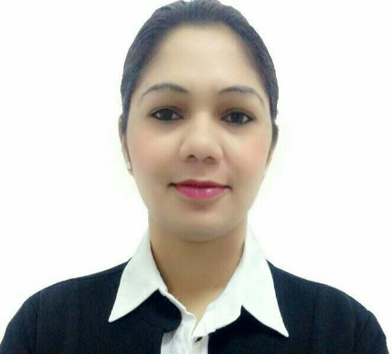
Name: Gleta Dsilva
Date of Birth: 11th September, 1987
Sex: Female
Nationality: Indian
Marital Status: Single
Current Location: Oman - Muscat
Passport No.: G1835538
Mobile No.: +968 94736508
Email address: gleta_dsilva@yahoo.com

PERSONAL PROFILE
________________________________________________________________________________________
Dynamic, Enthusiastic, Excellent communication skills, Good confidence level and Maintain high-level team spirit
. · Hard working and Result Oriented.
· Dedicated and self-Reliant.
· Strong interpersonal skills and flexible.
· Confident and optimistic team building.
· Excellent personal development & communication skills.
· Friendly and an extrovert person.
· A good Team player.
· Conducting team building activities.
· Attention to detail.
· Team & Time Management.

SUMMARY

To give my best in my professional pursuit for overall benefit and growth of the company that I serve by facing the challenges. I will show my caliber and gain some experience & Seeking a challenging position to work in globally competitive environment that will enhance my career whereby I can utilize my current skills and make significant contribution with strong work ethics and diligence that yield both job satisfaction and steady peace professional growth & To be an astute learner and the best performer in your organization. So that I can build an innovative career in your esteemed organization by using my skills and other significant talents.

EDUCATIONIONAL QUALIFICATIONS

Year 2005 “Guardian Angel Higher Secondary School” Goa – India (Goa Board)
H.S.C. Higher Secondary School Certificate

Year 2003 “Guardian Angel High School” Goa – India (Goa Board)
S.S.C. Secondary School Certificate

ADDITIONAL QUALIFICATION

2003 “InfoTech Computer Institute” – 1 month Training

IT Knowledge Basic Computer
Microsoft Office (Word, Excel)
Power Point Presentation

Language Skills English: Written & Spoken
Hindi: Written & Spoken
Konkani: Native Language

WORK EXPERIENCE

11/2007 – 02/2012 Office Assistant - Life Insurance Corporation of India – Goa, India
- Maintaining paper work
- Monitoring and inspection on payments
- Data entry regarding payments of installments
- Attending Phone Calls.
- Maintaining Appointment
- Customer service

01/2013 – 03/2015 Telephone Operator Cum Secretary - H.E. Dr. Omar Zawawi’s Estate
(HM Advisor of External Laison) and Chairman of OMZEST Group of
Companies, Muscat, Oman
- Billing & Preparing Vouchers for payments
- Handling petty cash and recording office expenditures
- Basic accounting for daily expenses
- Maintain and update of data
- Answer phones and transfer to the appropriate staff members
- Connecting conference calls
- Administrative duties including Fax, Filing and managing incoming and outgoing mails
- Handling inbound and outbound calls
- Maintain a high level of accuracy confidentiality concerning financial and employee files.
- Data entry for day to day transactions and attendance records
- Responsible for handling calls in a courteous, friendly and professional manner according to company procedures.
- Maintain a record of expiry of Passports, visas, labor cards, ID, health card etc.
- Coordinate & follow up with the PRO to ensure timely renewals.
- Maintaining knowledge of promotions producers.
- Handling Events &Presentations.
- Create and maintain database records.
- Maintaining staffs records
- Maintaining inventory records.
- Handling official get together.
- Ensuring opening and closing checklist are completed on daily basis.
- Following cash handling procedures.
- Escorting guests when and then required.
- Reporting to manager. &Undertaking daily routine works of faxes, scans and mailing.
- Handling official and Administrative work etc.
- Being a good professional by having a pleasant smile always
- Assisting HR manager approvals for employees proceeding on Annual leave, emergency leave, cancellations, renewing visa etc.
- Proper management of passports and other important documents.
- Coordinate with HR for new visa applications, labor cards, ID, employee arrival, cancellations etc.
- All other routine administration work.

SKILLS:

- Willingness to learn
- Working in a team environment.
- Excellent knowledge of office systems

HOBBIES & INTERESTS:

- Travelling
- Interacting with people

REFERENCES

- Available upon request

DECLARATION

I hereby declare that the above facts given by me are true to the best of my knowledge and belief.

Gleta Dsilva

