In the name of Allah the most merciful the most gracious

Objectives
Personal Information
“God willing to secure a position so that I may got an opportunity to utilize my skills and knowledge to their very best and prove how much of an asset I can employee of company because without a doubt I have all the confidence in my self and know what high standard is, and what is takes to live up to that standard”
Wandi Molvi Sahib Kot Chandna
P/o: Kala Bagh Teh: Isa Khel
Distt: Mianwali , Punjab , Pakistan.
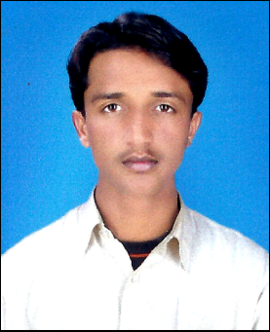
Name : Wasim Akram Father’s Name : Nizaam Din Date of Birth : 04/12/1989 CNIC # : 38301-0983835-5 Passport : DP1328351 Qualification : D.A.E (Civil) Contact # : 0336-7286565 Marital States : Merried Nationality : Pakistani Email Address : irfanullahkhan56@gmail.com Languages : Urdu,English,Saraiki,Punjabi. Domical : Mianwali,Punjab,Pakistan. Address :

Qualification
Degree / Diploma | Marks | Year | Collage / University
Metric | 455/850 | 2008 | BISE Sargodha
D.A.E (Civil) | 2449/3300 | 2012 | PBTE Lahore

Professional Qualification
- One Year Diploma of Surveyor Trade in Punjab Board of Technical Education Lahore with Pak Arab Training Center Rawalpindi.
Experience
- Worked in Recent Construction Co.(Pvt) Ltd.
From 08/02/2011 to 10/10/2013 as a Safety Supervisor.
Hobbies
- Cricket , Volly Ball , Islamic Books Reading , News Paper , PTV News only.
Reference
- Could be provided on demand.

