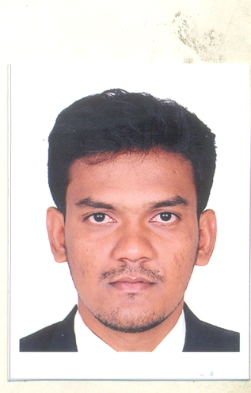
M A N I K U M A R. B - B.E (MechanicalEngineering) with 7 YearsExperience in Proposal, Estimation&Planning.
Contact: 77085-26786 rediconz@gmail.com

ADDRESS FOR COMMUNICATION
100,Kankollpattinam,
Puthupattinam (PO),
Namboothalai (Via),
Ramanathapuram(Dist)
Contact: 00968-94525179
rediconz@gmail.com

PROFILE:
Completed B.E (Mechanical Engineering) with first class in Institute of Road & Transport Technology in 2008 & Join in Cethar Limited & worked as Proposal, Estimation &Tendering Engineer up to November 2012.From November 2012 to September 2014 Worked as Proposal & Estimation in C&H Services in Thermax Limited.

Currently Working as Proposal, Estimation Engineer RAY International L.L.C, in OMAN.

The Following is the Job profile in the Organization.
Proposal, Estimation &Planning:
1. Proposal& Planning:
- Review the tender document for Boiler / Steam Turbine / Coolers & Heaters & all relevant portions of the tender received from Marketing.
- Prepare our Proposal as per the tender requirement.
- Co-ordinate with our Sub-Vendors for Bought out items..
- Review the Offer proposed by the sub-vendors for Bought out items.
- Compile the Offer prepared for the tender document
- Prepare L1, L2 & L3 Schedule for offered Package.

2. Estimation& Contract Management:
- Prepare the bill of quantities for the project.
- Prepare the enquiries for the Bought out items & Send to various vendors.
- Negotiate with vendors for both technical & commercial Part.
- Estimate for the Project.
- Compare our Estimate price with our earlier contract projects.
- Prepare budget for the Project
- Monitoring the Project.
- Co-ordinate with Sub contractors.
- Monitor the invoicing (respect to Off shore & Onshore products)
- Update the feedback (both technical & Commercial) if any, in our future proposal

QUALIFICATION:
COURSE | BOARD/  UNIVERSITY | INSTITUTION | PERFORMANCE  % | YEAR OF PASSING
B.E (Mechanical Engineering) | Anna University | Institute Of Road And Transport Technology, Erode | 76.98 | 2008
H.S.C | Matriculation | Alagappa Matriculation Higher Secondary School, Karaikudi. | 89.5 | 2004
S.S.L.C | Matriculation | Alagappa Matriculation Higher Secondary School, Karaikudi. | 85.6 | 2002
JOB STRENGTH:
  - Capability of doing Proposal & Estimation through ERP.
  - Cost Analysis through MS Software.
  - Had done Proposal for our Major Milestone Projects in CFBC / PC Subcritical & Supercritical Projects in EPC Basis.

MAJOR UTILITY PROJECTS HANDLED SO FAR:
  - M/s.ACB(India) Ltd -2x135MW EPC Package (CFBC Boiler)
  - M/s.SCL-2x150MW EPC Package (CFBC Boiler)
  - M/s.IBEUL-2x350MW Boiler Package (PC Fired Boiler)
  - M/s.JAL-2x60MW (CFBC Boiler)
  - M/s.SKS Power Gen (P) Ltd-4x300MW EPC Package (PC Fired Boiler)
  - M/s. IBEUL-1x660MW Boiler Package (Once Through Supercritical PC Fired Boiler)

FIELD OF INTEREST:
  - Power Plant Engineering
  - Economic & Cost Analysis

SOFTWARE EXPOSURE:
- MODELLING - Pro/Engineer 2001
- DRAFTING - AutoCAD 2004

CO –CURRICULAR ACTIVITIES:
Presented paper on Cost Optimization in
  - Bed Ash Cooling System in CFBC Boiler
  - Once Through Super critical PC Fired Boiler
  - Actively took part in Technical Programme on Steam turbine & Generator in Harbin Turbine Company Limited in China.
ACIEVEMENTS:
  - Done Proposal, Estimation & Tendering for the above mentioned Utility Projects.
  - Actively took part in launch of Supercritical technology from Cethar.

PERSONAL PROFILE:

Date of birth : 19/04/1986
Father’s Name : Mr.R.Boominathan
Mother’s name : Mrs.B.Selvakkannu
Hobbies : Painting, Listening music, Fishing
Language proficiency : English, Tamil
Passport details : H O534875 , Validity 21/09/2018
Marital Status : Single

I, MANIKUMAR.B do hereby declare that the above mentioned details are true to the best of my knowledge

Station : Oman

Date : (B.MANIKUMAR)

