RESUME
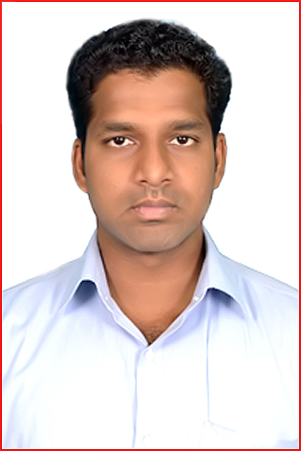
BHARATHI.R
Mob: +919751752580
Email:rbrb.ins@gmail.com
Objective:
To work in a challenging and growth oriented environment, unifying my progress with the team and organizations in which I work.
Educational Qualification:
Degree : Diploma in Instrumentation & Control Engineering.
(2008-2011)
Institution : Srinivasa Polytechnic College,
Srinivasa Nagar, Kalamavur-622502
Pudukkottai. (Dist)
Year of Passing : April 2011
Course : ITI in Instrument Mechanic [2004-2006]
Institution : Government Industrial Training Institute
Ambattur.Chennai-600098.
Year of Passing : July-2006.
Abroad experience:
COMPANY | Saudi Arabian Kentz
SITE | Saudi INternation Petrochemical Co.
DESTINATION | INSTRUMENT TECHNICIAN
PERIOD | June 2014 – present

COMPANY | Emco-Qatar
SITE | Qatar foundation
DESTINATION | INSTRUMENT TECHNICIAN
PERIOD | March’ 2012 to April’ 2014

Indian Experience :
COMPANY | Franklin Instrumentation Erection & Maintenance Pvt, Ltd.
SITE | CHENNAI PETROLEUM CORPORATION LTD
DESTINATION | INSTRUMENT TECHNICIAN
PERIOD | May’ 2011 to March’ 2012

COMPANY | Anacon Process Control Pvt Ltd.
SITE | CHENNAI PETROLEUM CORPORATION LTD
DESTINATION | INSTRUMENT TECHNICIAN
PERIOD | Aug’ 2006 to June’ 2008.

Worked Area:
- Refinery & Power plant instrumentation, maintenance, project, shut down.
- Worked FCCU, CRUDE & WAX. Plant.
- LEP, OM &S, ETP, TTP and Analysers.
Nature of Work:
- Calibration of pressure, level and Temperature gauges.
- Calibration of field instruments like Switches for pressure, level, and flow.
- Wiring and termination of cables in junction boxes, panels etc.
- Calibration of field instruments Transmitters for pressure, flow, level and Temperature.
New Project:
- Experience in loop checking and comminsioning of all field instruments
- Have experience in carrying out the instrument erection and commissioning activities with reference to the following construction document instrument cable schedule.
- Instument / JB Location drawings
- Logic Drawing
- Control scheme drawing
- Hook up drawing

Personal Details :
Name : BHARATHI. R
Father’s Name : RAJENDRAN. N
Address : 1/36, NORTH STREET
KANNARAMPATTU (Po),
ULUNDURPET (TK)
VILLUPURAM – 607 203.
Date of Birth : 30.07.1986
Sex : Male
Religion : Hindu
Nationality : Indian
Marital Status : Single
Languages : Tamil & English
Mobile : +919751752580
Mail – ID : rbrb.ins@gmail.com
Passport Details :

Passport No : J9410657
Date of Issue : 18/11/2011
Place of Issue : Chennai
Date of Expiry : 17/11/2021

Declaration

I hereby declare that information provided above is True, Complete and Correct to the best of my Knowledge and belief.

Thanking you
Yours Sincerely,

Place : ( BHARATHI. R )
Date :

